The Influence of Financial Literacy, Self-Efficacy and Lifestyle on The Financial Management Behavior
Ni Putu Widhia Rahayu¹, Viacenza²

Management Department, Faculty of Economics and Business, University of Bandar Lampung

Corresponding author: niputu@ubl.ac.id

Received: month, year; Revised: Month, year;
Accepted: month, year; Published: month, year
Abstract

The management of finances represents a significant challenge in student life, influenced by various factors. A primary concern is the limited capacity for financial management, which often stems from insufficient knowledge of more advanced financial concepts. Consequently, this research seeks to explore and analyze the interplay between financial literacy, self-efficacy, and lifestyle in relation to financial management behaviors, while also considering locus of control as a mediating factor. The study focuses on students enrolled in the Faculty of Economics and Business at the University of Bandar Lampung. A random sampling method was employed, utilizing Slovin's formula to determine sample size. Data analysis was conducted using Smart-PLS version 4.1.0.3, applying the SEM-PLS (Structural Equation Modeling-Partial Least Square) technique. A total of 128 student respondents were successfully surveyed. The results reveal a significant relationship between financial literacy, self-efficacy, and lifestyle with financial management behaviors. However, the mediating variable did not demonstrate an effect on the dependent variable, indicating that students with a more profound understanding of the independent variables are capable of managing their finances effectively, independent of their self-confidence levels.
Keywords: Financial Literacy, Self-Efficacy, Lifestyle, Financial Management Behavior, Locus of Control.
Introduction
Financial management is one of the things that often becomes a problem in everyday life, especially for students. Students often experience difficulties in managing their finances. Some of the reasons underlying this are students' lack of knowledge about financial management, low self-confidence, and lifestyles that exceed their income.
Starting from financial literacy that can influence students' financial management behavior, where the better they manage their finances, the more rational their financial decisions will be. When someone has good literacy, it is necessary for that person to have confidence in themselves that they can manage their finances well. This statement aligns with the theory of behavioral finance. This is also closely related to self-efficacy. When the level of self-efficacy is high, it also improves the process of managing personal finances. Then, in today's era, lifestyle plays a very important role in students' lives to show their existence. This creates problems in managing students' personal finances, where they still cannot control themselves well between wants and needs. Many students often buy a lot of things just to improve their lifestyle in the eyes of others rather than for their actual needs. This will lead to a consumptive lifestyle. Therefore, when a lifestyle is proven to have a good relationship with financial management behavior, it can be demonstrated that a person who can manage their personal finances well will also have an impact on their own lifestyle.
Numerous factors outlined previously significantly impact contemporary students, taking into account the diverse influences stemming from both external and internal sources. Consequently, the establishment of a locus of control is essential to achieve equilibrium in this context. Specifically, a locus of control related to financial management can illuminate students' characteristics, ensuring they are adequately prepared to navigate their financial capabilities, influenced by both their environment and personal attributes (Hidayat & Paramita, 2022). Students exhibiting a higher internal locus of control (focusing on personal agency) are likely to demonstrate greater proactivity in financial management compared to those with a predominant external locus (emphasizing environmental factors). The concept of locus of control serves as a foundational element for the three aforementioned aspects, particularly in relation to self-efficacy, thereby acting as a mediating variable between independent and dependent variables. Furthermore, locus of control has been identified as an effective and robust "bridge" that connects financial literacy, self-efficacy, and personal financial management behaviors. However, when examined through the lens of Indonesia's cultural and social context, which tends to favor collectivism, individuals are inclined to prioritize their social relationships. Such a context necessitates the presence of a locus of control to mediate the interactions between financial literacy and self-efficacy concerning financial management behaviors, encompassing both internal and external dimensions (Mareta et al., 2023).
The researcher aims to investigate the relationship between the previously mentioned variables and financial management behavior, leading to the identification of the research problem as "The Influence of Financial Literacy, Self-Efficacy, and Lifestyle on the Financial Management Behavior of Students in the Faculty of Economics and Business at the University of Bandar Lampung." This focus arises from the researcher’s intent to explore the phenomenon within the local context, particularly in the Faculty of Economics and Business, which provides foundational knowledge in financial management alongside a more nuanced comprehension of the subject. This academic setting prompts an inquiry into whether individuals with basic financial management knowledge exhibit different behaviors. Additionally, the age of the respondents is highlighted as a critical factor influencing their personal finance management, taking into account various life stages, including employment status and other relevant criteria. Furthermore, the researchers note that Indonesia's economic landscape remains challenging, characterized by inflationary pressures that complicate financial decision-making, leading to difficulties in distinguishing between essential and non-essential expenditures. Therefore, after identifying the above problems, the objectives to be achieved in this research are (1) "To obtain results on the influence of financial literacy on the financial management behavior of students in the Faculty of Economics and Business at the University of Bandar Lampung." (2) To determine the influence of financial attitudes on the financial management behavior of students in the Faculty of Economics and Business at the University of Bandar Lampung. (3) To determine the influence of lifestyle on the financial management behavior of students at the Faculty of Economics and Business, University of Bandar Lampung. (4) To determine the influence of locus of control mediating financial attitudes on the financial management behavior of students at the Faculty of Economics and Business, University of Bandar Lampung.
There are several studies that underlie this research, among others: Research by Rina and Sherlyn (2023), Research by I Gede Adiputra (2021), Research by Siri Maghfirotul Ummah and friends (2021), Arofah, A.A (2019), Tifani and Fitri (2019) and others.

Financial literacy is the knowledge, skills, and belief to influence someone in aspects of attitude and behavior to make decisions and manage finances with better quality (Financial Services Authority, 2014). According to the Education Development Center (2019), financial literacy itself is the process of individuals using their potential and skills fully to enhance their lives, not just reading and writing. The World Bank and the Organization for Economic Cooperation and Development (OECD) are international organizations that serve as platforms for surveys to assess the level of literacy among the Indonesian population. In its research, there are four levels: proficient literacy, moderately proficient literacy, less proficient literacy, and completely non-proficient literacy in terms of financial literacy. This is carried out directly by the Financial Services Authority (OJK). Based on the theories that have been presented above, there are two indicators that can be used in evaluating financial literacy, namely general knowledge of finance and investment.
Self-efficacy is defined as an individual's conviction in their ability to execute the necessary actions to attain objectives and navigate various obstacles. A comprehensive understanding of oneself facilitates accurate self-recognition, thereby minimizing erroneous assessments of one's abilities, which is a crucial aspect (Baron and Donn in Letari et al., 2023). The concept of "self-efficacy" encompasses the repetitive activities inherent in human existence, grounded in moral principles cultivated internally, including consistency, simplicity, loyalty, self-discipline, bravery, fairness, patience, expertise, courtesy, and integrity (Doto et al., 2023). This concept emphasizes the significance of social experiences, observational learning, and mutualistic interactions in shaping an individual's character, which is a core element of Albert Bandura's social cognitive theory (Septian et al., 2023). In the financial domain, indicators for assessing self-efficacy encompass confidence in financial planning, adeptness in financial management, achievement of established goals, proficiency in making spontaneous financial decisions, assurance regarding future financial circumstances, and the capability to address various financial challenges (Lown in Ulumudiniati et al., 2022).
According to Kotler and Keller (2018), lifestyle is a way of life of an individual that is reflected through their activities, interests, and opinions. Where the visible behaviors are a mix of habits that have been mutually agreed upon or planned together. The lifestyle referred to here is a person's consumptive pattern in an activity by wasting money and time (Mufidah and Wulansari, 2018). Lifestyle also includes how someone expresses themselves in activities, pursues their interests, and voices their opinions. In this case, it means that an individual is viewed from their daily activities, what is in their mind about everything in their life, and they become concerned (Kanserina, 2015).
Self-financial management behavior centers on the individual's approach to overseeing personal finances, highlighting the psychological factors that can affect financial decision-making at both the organizational and market levels (Wicaksono and Divarda, 2015). Suryanto and Rasmini (2018) further define self-financial management behavior as the practices or habits individuals adopt in managing their finances. This behavior encompasses various competencies, including the ability to plan, budget, assess, manage, monitor, seek out, and save financial resources on a daily basis (Kholilah and Iramani in Pradiningtyas et al., 2019). The management of finances is intrinsically linked to an individual's responsibility to oversee their financial resources (Joseph, 2020; Waspada and Mulyani, 2020). Key indicators of self-management behavior include the establishment of financial goals for the business, precise estimation of monthly income, accurate forecasting of operational expenses, strategic planning and budgeting for raw materials or products, evaluating multiple options when making financial choices, and effectively executing the expenditure plan for designated time frames.
Locus of control refers to an individual's belief in their ability to control events that occur, whether they originate from within themselves or from external factors (Duffy and Atwater in Mutlu et al., 2019). This concept is part of the theory developed by JB. Rotter, which focuses on social learning. According to his theory, one's own personality will involve and represent expectations regarding factors that will determine success, rewards, or punishments in individual life (Pervin in Novianti, 2019). Locus of control is related to a person's perspective that makes them believe that every event that occurs is a result of their own actions (Pradiningtyas and Lukiastuti, 2019). Locus of control in other variables will influence financial management behavior. The locus of control varies according to how individuals perceive their personal responsibility in facing events, based on Rotter's social learning theory (Rotter in Mutlu et al., 2021). According to Sanjiwani and Wisadha (2016), there are several indicators to measure locus of control, which can be categorized into two types: internal and external. Internal itself is found in self-confidence in completing tasks, one's ability to make choices about events, and also having full control over oneself. Meanwhile, in the external aspect, it lies in the strength from outside oneself and also luck. Similar to what Sanjiwani and Wisadha stated, according to Rotter in Pradiningtyas and Lukiastuti (2019), locus of control is also differentiated into two with the same meaning but with different initials and points of emphasis. The locus of control in the internal itself has a point on internality (I), while in the external itself, it is on powerful others (P) and chance (C).

In the financial system, there is something called financial literacy, which contains basic knowledge about the financial systematics. This is important for daily life if studied more deeply and influences a person's behavior in managing their finances. Several studies that have been conducted have shown that aspects of financial literacy and financial management behavior have a significant and positive impact. The studies in question are Mashud et al. (2021), Hidayat and Paramita (2022), and Ulumudiniati (2022).
H1: Financial literacy affects the financial management behavior of students in the Faculty of Economics and Business at the University of Bandar Lampung.

Self-efficacy, which briefly emphasizes a person's belief in their own abilities, is often associated with an individual's behavior in managing their own finances. With high self-efficacy, individuals are also more active in managing their finances, from investments to other financial matters. This is in line with previous research conducted by Ismail et al. (2017) and Ummah et al. (2021).
H2: Self-efficacy affects the financial management behavior of students in the Faculty of Economics and Business at the University of Bandar Lampung.

Lifestyle has several aspects, one of which is lifestyle patterns. Where lifestyle is closely related to trends that will encourage someone to spend on things that are actually unnecessary and tend to be uncontrolled. Therefore, the lifestyle related to financial management is combined to see the relationship. This is supported by previous research by Sufyati and Lestari (2022) and Irawati and Kasemetan (2023).
H3: Lifestyle influences the financial management behavior of students at the Faculty of Economics and Business, University of Bandar Lampung.

Knowledge about finance is a good understanding for someone who wants to make decisions and choose what kind of financial path to take. This will be achieved through financial literacy. Someone who gains good knowledge will also gain the strength that what they do will go well, thereby fostering a person's confidence to take control of their own finances. This point is related to the locus of control itself. This statement is supported by previous research, namely the studies by Irawati and Kasemetan (2023), Rochmawati and Khoirunissa (2021), and Lukiastuti (2019).
H4: Financial literacy affects the locus of control of students in the Faculty of Economics and Business at the University of Bandar Lampung.

Locus of control has two aspects, internal and external. In the internal aspect, there is a strong connection to self-efficacy because a person with high self-efficacy believes that all their activities will yield good results, thus providing motivation to seize opportunities and enthusiasm to overcome obstacles. From this, previous research has examined and produced positive and significant results, namely Sari (2022).
H5: Self-efficacy affects the locus of control of students in the Faculty of Economics and Business at the University of Bandar Lampung.

Lifestyle always has an unexpected impact on a person's financial management, from following trends to daily needs. This is related to the locus of control, which focuses on self-belief regarding the control over one's life events. Where the frequently occurring trends and numerous media offerings make a person's lifestyle more significant in influencing their spending. This statement is supported by previous research conducted by Irawati and Kesemetan (2023), Cahyani (2022), and Khoirunnisa (2021).
H6: Lifestyle influences the locus of control of students in the Faculty of Economics and Business at the University of Bandar Lampung.

When someone has a high locus of control, their financial management will be much better, and their financial success will be within their own reach. This is because someone who is confident in their abilities will also be confident in the results of their financial management, as it is well-documented and well thought out. This is supported by research whose results have a positive and significant impact, namely the studies by Mufidah (2018), Mutlu and Ozer (2021), and Hidayat and Paranita (2022).
H7: Locus of control affects the financial management behavior of students at the Faculty of Economics and Business, University of Bandar Lampung.

Based on the explanation above, it can be described in a conceptual framework in Figure 1. In simple terms, this researcher looks at the relationship between the 5 existing variables as a whole as below.
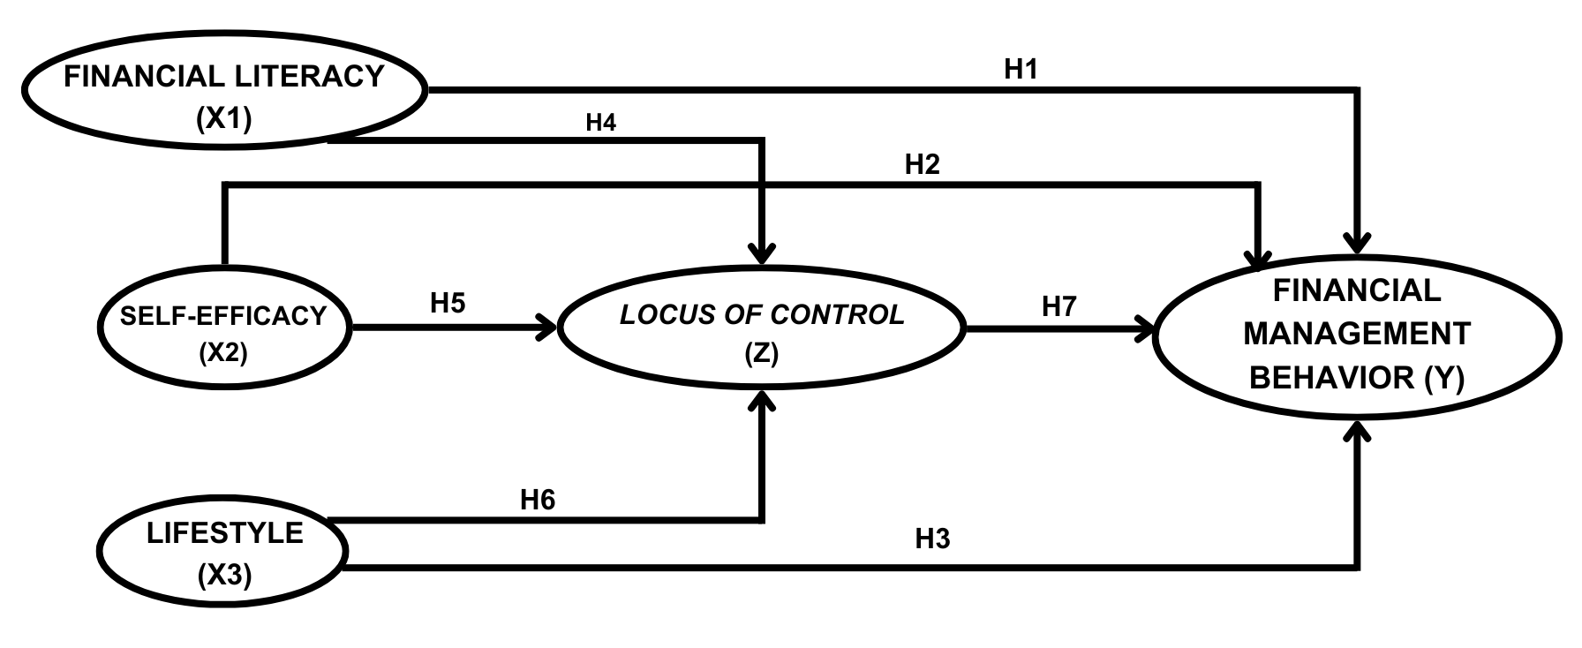
Figure 1. Conceptual Framework

Methods
In this research, a quantitative methodology was employed, incorporating initial observations alongside descriptive statistical analysis. The analytical method utilized was SEM-PLS (Structural Equation Modeling-Partial Least Squares). The target population comprised active students from the Faculty of Economics and Business at Bandar Lampung University, specifically those enrolled in the classes of 2021 to 2023, totaling 718 students. A random sampling technique was applied to select the sample, calculated using the Slovin formula, resulting in a sample size of 128 students representing all academic programs at Bandar Lampung University, adhering to specified criteria. Data analysis was conducted using the Smart-PLS version 4.1.0.3 software. Data collection was facilitated through Google Forms, employing a Likert scale ranging from 1 to 5, where a score of 1 signifies strong disagreement and a score of 5 indicates strong agreement.
The researcher chose the data analysis technique with SEM-PLS (Structural Equation Modeling-Partial Least Square) due to the large number of variables and also the large number of respondents, whereby using this analysis technique, the researcher can simultaneously understand the relationships between variables and account for the effects of latent variables on indicator variables. In addition, the advantage of using SEM-PLS (Structural Equation Modeling-Partial Least Square) in research is that it allows for the observation of potential outcomes between the relationships of the tested variables.
Next, in the research using Google Form itself, there were obstacles with some respondents who tended to fill it out less seriously. This is marked by the collected data, where some respondents filled in the same scale for each statement without any variation. Due to this occurrence, when the respondents reached only 108 students, the researchers added 19% to that number because during testing there was an imbalance in the test results, resulting in 128 respondents with all valid test results and responses that aligned with the understanding of students from the Faculty of Economics and Business at the University of Bandar Lampung, without any deletion of invalid or insignificant data. Not only in the number of respondents, but this also applies to several statements in the indicators per variable. The results of the questionnaire show that some data are unevenly distributed, making some test results invalid, leading to the reduction of variable indicators in several statements.

Result and Discussions
Results
Outer Model
In the questionnaire that has been distributed according to the research criteria, 38 statements were obtained with test results that meet the requirements. However, based on the first test, there were some data that did not meet the qualifications and resulted in data processing that did not meet the data testing standards, so that several statements were removed from the previous ones to get 19 statements from the total sub-variables.

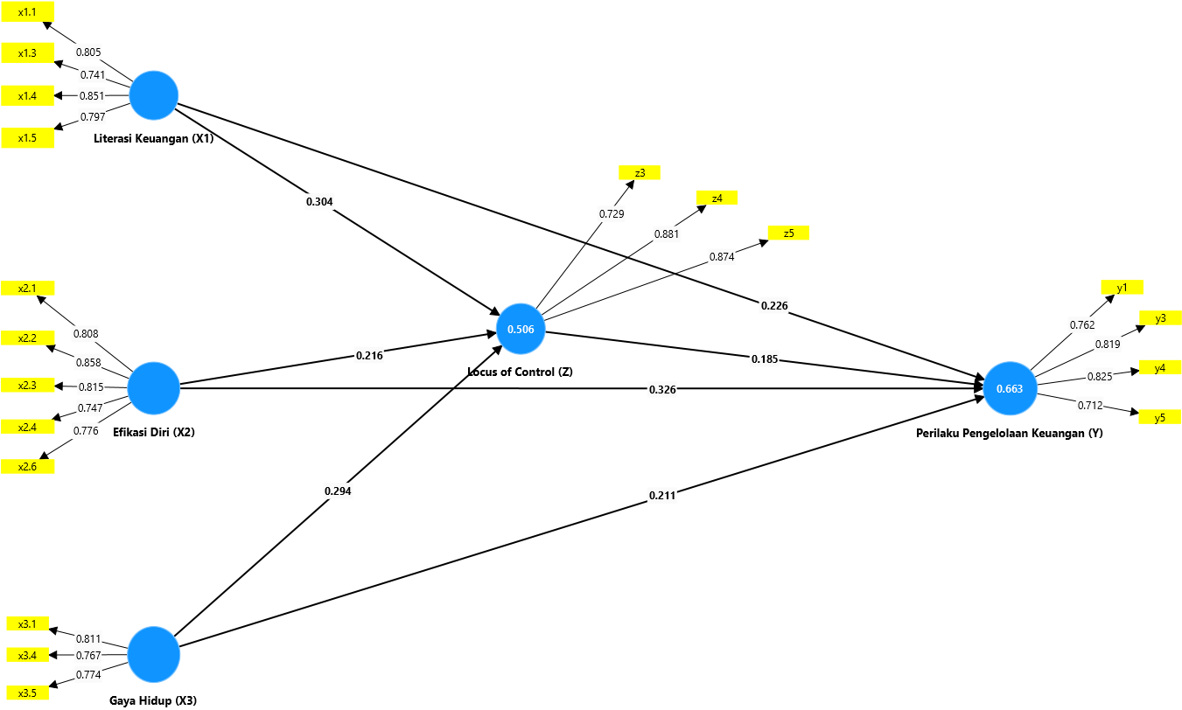

Figure 2. Outer Loading Test Result

Based on the results of the outer model test, all variables in the model meet the validity criteria. Overall, all variables in the model show good validity. Where in the outer model testing itself, if the indicator value is more than 0.7, then the indicator can be used for other tests, tests that will show the correlation relationship between the indicator and its construct. This statement is in accordance with Figure 2, where all the indicators that have been established after the trimming of indicators from the original data are declared valid, and all the indicators can be used to observe the correlation with one another.

Inner Model
R-Square
Hair et al stated that the r-square value with strong model prediction accuracy is at a value of 0.75, medium is at a value of 0.50 and the low level is at a value of 0.25.

Table 1. R-Square Value
 | R-Square | R-Square Adjusted
LoC (Z) | 0.506 | 0.494
FMB (Y) | 0..663 | 0.653

The analysis of table 1 indicates that the R-Square value reveals the mediation variable accounts for 50.6% of the variation in the construct, categorizing it within the medium prediction range. In contrast, financial management behavior exhibits an R-Square value of 66.3%, reflecting a similar level of moderate predictive accuracy. The remaining percentage of variation is attributable to other variables not included in the model, which may influence the outcomes of the two examined variables.

F-Square
Hair et al not only stated about r-square but also stated about f-square, where the value of f-square has a small impact at 0.02, medium at 0.15 and a large one at 0.35.

Table 2. F-Square Value
Variable | F-Squuare | Effect
S-E (X2) -> LoC (Z) | 0.038 | Low
S-E (X2) -> FMB (Y) | 0.122 | Low
L (X3) -> LoC (Z) | 0.090 | Low
L (X3) -> FMB (Y) | 0.062 | Low
FL (X1) -> LoC (Z) | 0.094 | Low
FL (X1) -> FMB (Y) | 0.070 | Low
LoC (Z) -> FMB (Y) | 0.050 | Low

Based on the presented f-square value testing table, it can be concluded that all variables show low values, indicating that almost all of their effects are classified as weak. This indicates that the function of the F² value itself cannot provide a significant contribution and can even be ignored. However, this is not a major issue for the researchers or this study because the small effect can still be considered for use since there are still several tests being conducted.

Hypothesis Test

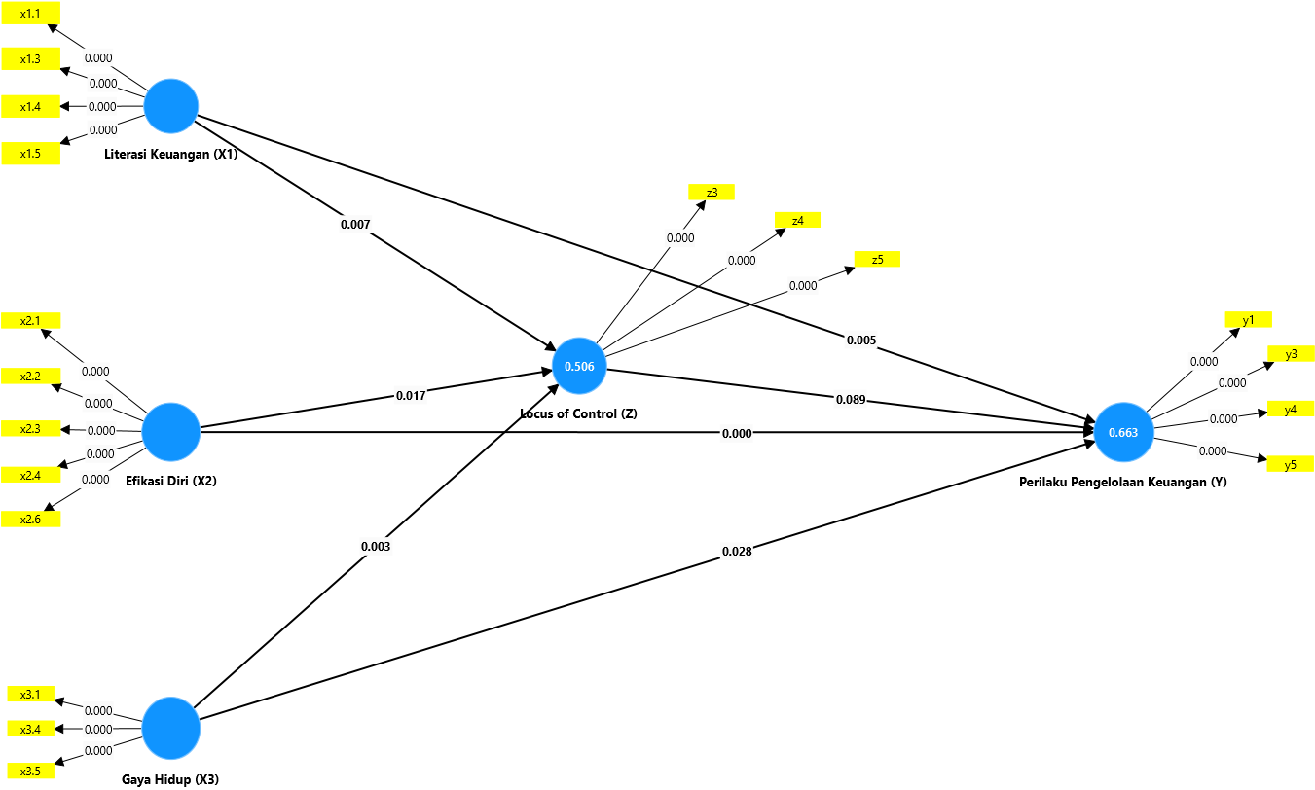

Figure 3. Hypothesis Test Results in Smart-PLS 4.1.0.3

Hypothesis testing is a form of testing to see and evaluate the relationship between variables, which wants to see whether the effect is significant or not. The general provision in this case is that a p value of less than 0.05 means that it is accepted and significant and if it is more than 0.05, it is rejected and not significant. This was conveyed by Hair et al.

Table 3. Hypothesis Test Results
Hypothesis | Original sample (O) | Sample mean (M) | Standard devitation (STDEV) | T-statistics (|O/STDEV|) | P values
S-E (X2) -> LoC (Z) | 0.216 | 0.214 | 0.090 | 2.387 | 0.017
S-E (X2) -> FMB (Y) | 0.326 | 0.331 | 0.094 | 3.487 | 0.000
L (X3) -> LoC (Z) | 0.294 | 0.292 | 0.097 | 3.023 | 0.003
L (X3) -> FMB (Y) | 0.211 | 0.213 | 0.096 | 2.203 | 0.028
FL (X1) -> LoC (Z) | 0.304 | 0.306 | 0.113 | 2.687 | 0.007
FL (X1) -> FMB (Y) | 0.226 | 0.227 | 0.081 | 2.788 | 0.005
LoC (Z) -> FMB (Y) | 0.185 | 0.180 | 0.109 | 1.702 | 0.089

In hypothesis testing itself, there are several terms that will influence the interpretation of the hypothesis test results. Starting from the original sample, where the value of O is the value that will determine the positive or negative direction of the relationship between the tested variables. If the result of the O value is positive, then the relationship between the variables will also be positive, and vice versa. Then, the sample mean (M) is the average value calculated from the existing population data, which means the value of M will provide an overview of the characteristics of the calculated variable, such as the sum of all values in the sample divided by the original data. If the value of M increases according to the specified scale, it indicates that the majority of respondents agree with the statements in the distributed questionnaire. Next, there is the standard deviation (STDEV), whose value will indicate the standard deviation between the indicators measured in the research model as seen from the average value. A brief explanation regarding the value of STDEV itself is that if its value is less than 1, it indicates a low value, and the values in the dataset are closer to the mean, meaning respondents have views that align with the statements of the measured variable and vice versa. If the STDEV value is large or more than 1, then the spread is too wide, and effort is needed to see significant differences in respondents' opinions with the measurements tested by the researcher. Finally, there is the T statistic, which indicates whether or not there is a significant difference between the tested variables. The t value itself will depend on the t table value. Where if the t statistic value is greater than the t table value, it is identified as significant, but conversely, if it is smaller, it is not significant.

Based on Table 3 and the explanation regarding the components above, it can be concluded that the six existing hypotheses are accepted positively and significantly, unlike the seventh hypothesis, which has a positive value but is rejected. This rejection occurs because the p-value itself is greater than 0.05, which is 0.089. Further explanation regarding this test will be provided in the "Discussion" section.

Discussion
Financial Literacy on Financial Management Behavior
In the testing of the above hypothesis, the independent variable has a truly strong and positive influence on the dependent variable. Starting from financial literacy, which indicates that when students fill out the questionnaire, the majority agree with the statements provided. This indicates that when someone has a strong understanding of basic finance, their personal finances can be managed well because of the awareness of the meaning of finance in accordance with existing aspects, such as income and expenses. A simple way to connect these two variables is by providing basic financial literacy education from an early age, such as during elementary school, where the importance of saving is taught and practiced as simply as possible to motivate them to manage their finances well. From this simple method, it can later be further developed into the next stages, such as how to manage personal finances wisely and invest correctly, as well as several other methods that can be applied according to the situation and environmental conditions of the research target. This statement is in accordance with the research findings of Hidayat and Paramita (2022), Ulumudiniati (2022), and Mashud et al. (2021).

Self-efficacy on Financial Management Behavior
The second independent variable demonstrates a significant impact on the dependent variable. This indicates that within the research context, participants concur that individuals possessing high self-efficacy are adept at managing their personal finances effectively. This encompasses the formulation of financial plans and the attainment of desired objectives. In essence, when students are capable of making informed financial decisions, the management of their personal finances becomes considerably more straightforward and systematic. This conclusion aligns with the findings of Ismail et al. (2017) and Ummah et al. (2021).

Lifestyle on Financial Management Behavior
The third independent variable, lifestyle, aligns with the previously mentioned variables, influencing behaviors related to effective financial management. This suggests that an individual's lifestyle significantly impacts their financial management practices, as students who possess an awareness of their lifestyle are more adept at handling their personal finances. Essentially, students who can regulate their daily expenditures tend to exhibit superior financial management skills, both in the short and long term. This finding is supported by the research conducted by Irawati and Kasemetan (2023) as well as Sufyati and Lestari (2022).

Financial Literacy on Locus of Control
The test results mean that the relationship between the two variables is good, positive, and significant. This means that people who have high general financial knowledge will be responsible for their own finances so that students can trust themselves in managing their finances. This is equivalent to what was found by Irawati and Kasemetan (2023), Rochmawati and Khoirunissa (2021), and Lukiastuti (2019).

Self-efficacy on Locus of Control
After the hypothesis is tested, it is proven that students with a large level of efficacy are easier to control their personal financial activities because students trust themselves in managing finances and are aware of their personal financial condition. With a high level of confidence, the confidence to solve financial management problems is getting better too. This is supported by the theory of Julian B. Rotter and research conducted by Sari (2022).

Lifestyle on Locus of Control
Lifestyle related to locus of control shows a relationship that can support a person in managing money spending for daily needs, especially in managing wants and needs. The influence of internal and external factors on a hedonic lifestyle can make it more difficult for individuals, but with a locus of control, the situation becomes more structured. This finding is in line with research by Irawati and Kesemetan (2023), Cahyani (2022), and Khoirunnisa (2021).

Locus of Control on Financial Management Behavior
The results show that there is a positive influence between locus of control and financial management behavior, but the hypothesis was rejected because it did not meet the specified requirements. This means that there are other more significant factors that influence other variables, where individuals who can manage their finances will be fine without the encouragement from the locus of control factor as a belief in managing their finances in certain situations. In addition, there are other influences from more dominant values for several variables and other external aspects that are not further explained. In simple terms, the testing of this second variable indicates that although students of the Faculty of Economics and Business at the University of Bandar Lampung have a high belief in self-control, it does not always mean they can manage their finances well or that it is reflected in their self-control. This is influenced by several aspects, both internal and external to the individual, such as environmental factors. If viewed from a theoretical perspective, there are several theories that support the statement in testing this variable, namely the theory from Julian Rotter, which focuses on social learning. Where this theory states that a person's behavior will be influenced by expectations of outcomes and values. Then, there is the theory proposed by Eysenck (Big Five), which states that personality theory will show that a person's personality traits will influence an individual to react to situations. Therefore, locus of control cannot always be a mediating variable that connects several other variables. This finding is consistent with the research conducted by Baptista et al. (2021).

Conclusion
Based on the results of the research and analysis that have been carried out, it can be concluded that:
- Financial literacy, self-efficacy, and lifestyle have a positive and significant influence on students at the Faculty of Economics and Business, Bandar Lampung University, in managing their personal finances, even though with different backgrounds. Which shows that the respondents can manage their personal finances well, starting from the respondents being able to sort out their needs and desires in their daily lives so that they have good self-control in spending money that is not really needed. This is in line with understanding financial literacy.
- The three independent variables influence and are mediated by locus of control, which acts as confidence and self-control in decision-making and financial management steps.
- The analysis of the dependent variable reveals that locus of control does not exert a significant effect; however, a positive correlation exists between the two constructs. This phenomenon can be attributed to the attitudes of students at the Faculty of Economics and Business, Bandar Lampung University, who exhibit a higher score on the independent variable in comparison to the mediating variable. Consequently, locus of control is unable to exert influence in the absence of support from additional independent variables.

The suggestions from researchers that can be given from the results of this study are:
- For future researchers, the independent variables should be tested again with different settings, including aspects of income, status, and factors that influence student financial management behavior and locus of control more deeply and significantly. Then, you can pay more attention to data collection, ensure that the respondents used are relevant to the research, and check the statements of each item in interpreting each variable so that the research runs well. Finally, the next researcher can replace the mediating variable "locus of control" and retest it like other mediating variables such as matters related to financial technology, financial attitudes, and the social environment.
- For the readers, managing finances is crucial in everyday life, especially for college students, so in order to be prepared for the future, it is important to start understanding the basics of finance.
Acknowledgement
I would like to thank God, my parents, friends, and especially the lecturers who have guided and supported me in this research, as well as all the respondents who have taken the time.

References

’Ulumudiniati, M., & Asandimitra, N. (2022). Pengaruh Financial Literacy, Financial Self-Efficacy, Locus of Control, Parental Income, Love of Money terhadap Financial Management Behavior: Lifestyle sebagai Mediasi. Jurnal Ilmu Manajemen, 10(1), 51–67. https://doi.org/10.26740/jim.v10n1.p51-67
Alifa Salsabila Hidayat, & R.A Sista Paramita. (2022). The Analysis of Financial Literacy, Financial Attitude and Locus of Control Toward Financial Behavior on UNESA’s Economic and Business Students. Accounting and Finance Studies, 2(3), 157–176. https://doi.org/10.47153/afs23.4392022
Amagir, A., Groot, W., van den Brink, H. M., & Wilschut, A. (2020). Financial Literacy of High School Students in The Netherlands: Knowledge, Attitudes, Self-Efficacy, and Behavior. International Review of Economics Education, 34(April 2019), 100185. https://doi.org/10.1016/j.iree.2020.100185
Arofah, A. A. (2019). Financial literacy, self-efficacy, and financial behaviour of college students. International Journal of Pedagogy and Teacher Education, 3(2), 129–138. https://jurnal.uns.ac.id/ijpte/article/view/17546
Austin, J. N., & MN, N. (2021). Perilaku, Sikap Dan Pengetahuan Keuangan Terhadap Kepuasan Keuangan. Jurnal Manajerial Dan Kewirausahaan, 3(1), 61. https://doi.org/10.24912/jmk.v3i1.11288
Baptista, S. M. J. (2021). The Influence of Financial Attitude, Financial Literacy, and Locus of Control on Financial Management Behavior (Study Case Working-Age of Semarang). International Journal of Social Science and Business, 5(1), 93–98. https://doi.org/10.23887/ijssb.v5i1.31407
Dare, S. E., van Dijk, W. W., van Dijk, E., van Dillen, L. F., Gallucci, M., & Simonse, O. (2023). How Executive Functioning and Financial Self-efficacy Predict Subjective Financial Well-Being via Positive Financial Behaviors. Journal of Family and Economic Issues, 44(2), 232–248. https://doi.org/10.1007/s10834-022-09845-0
Hendrawati, E. (2019). Pengaruh Locus Of Control Terhadap Self Eficacy Dan Motivasi Berprestasi. Journal of Chemical Information and Modeling, 53(9), 1689–1699.
Hilmi, R. Z., Hurriyati, R., & Lisnawati. (2018). Pengaruh Locus Of Control Dan Pengetahuan Keuangan Terhadap Perilaku Pengelolaan Keuangan Mahasiswa. 3(2), 91–102.
Kanserina. (2015). Perilaku Konsumtif Mahasiswa Jurusan Pendidikan Ekonomi UNDIKSHA 2015. 5(1).
Lesmana, T. (2023). Analisis Perilaku Konsumen Generasi Milenial Dalam Berbelanja Online. Jurnal EBI, 5(2), 46–56. https://doi.org/10.52061/ebi.v5i2.175
Lestari, S. I., & Pramukty, R. (2023). Pengaruh Locus of Control, Kepemimpinan Situasional, Dan Efikasi Diri Terhadap Kepuasan Kerja. Musytari: Neraca Manajemen, Akuntansi, Dan Ekonomi, 1(8), 1–10.
Lown, J. M. (2011). 2011 Oustanding AFCPE® Conference Paper: Development and Validation of a Financial Self-Efficacy Scale. Journal of Financial Counseling and Planning, 22(2), 54–63.
Mashud, M., Mediaty, M., & Pontoh, G. T. (2021). The Effect of Financial Literature, Lifestyle and Income of Parents on Student Financial Management Behavior. Journal of International Conference Proceedings, 4(3), 256–264. https://doi.org/10.32535/jicp.v4i3.1315
Noor, N., Batool, I., & Arshad, H. M. (2020). Financial Literacy, Financial Self-efficacy and financial account ownership behavior in Pakistan. Cogent Economics and Finance, 8(1). https://doi.org/10.1080/23322039.2020.1806479
Nurjanah, R., Surhayani, S., & Asiah, N. (2022). Faktor Demografi, Literasi Keuangan, Sikap Keuangan Terhadap Perilaku Pengelolaan Keuangan Pada Umkm Di Kabupaten Bekasi. Jurnal Akuntansi Bisnis Pelita Bangsa, 7(01), 1–16. https://doi.org/10.37366/akubis.v7i01.431
Pinasti, W. (2011). Pengaruh Self-efficacy, Locus of Control dan Faktor Demografis Terhadap Kematangan Karir Mahasiswa UIN Syarif Hidayatullah Jakarta. Skripsi.
Pradiningtyas, T. E., & Lukiastuti, F. (2019). Pengaruh Pengetahuan Keuangan dan Sikap Keuangan terhadap Locus of Control dan Perilaku Pengelolaan Keuangan Mahasiswa Ekonomi. Jurnal Minds: Manajemen Ide Dan Inspirasi, 6(1), 96. https://doi.org/10.24252/minds.v6i1.9274
Putra, R. D. S., Naufal, A., Ratnawati, T., & ... (2024). Pengaruh Literasi Keuangan, Gaya Hidup Terhadap Perilaku Keuangan Pada Generasi Milenial (Studi Pada Mahasiswa Universitas di …. Musytari: Neraca …, 3(5). https://ejournal.warunayama.org/index.php/musytarineraca/article/view/1736%0Ahttps://ejournal.warunayama.org/index.php/musytarineraca/article/download/1736/1621
Rahman, A., Yousida, I., Kristansi, L., & Paujiah, S. (2020). Pengaruh Pengetahuan Keuangan, Perencanaan Keuangan Dan Kontrol Diri Terhadap Perilaku Pengelolaan Keuangan Pada Mahasiswa Yang Menjalankan Praktik Bisnis Dikota Banjarmasin. Jurnal Mitra Manajemen, 4(9), 1405–1416. https://doi.org/10.52160/ejmm.v4i9.466
Sufyati HS, & Alvi Lestari. (2022). Pengaruh Literasi Keuangan, Inklusi Keuangan dan Gaya Hidup Terhadap Perilaku Keuangan Pada Generasi Milenial. Jurnal Multidisiplin Madani, 2(5), 2415–2430. https://doi.org/10.55927/mudima.v2i5.396
Susanti, R., & Wangdra, R. (2024). Pengaruh Literasi Keuangan, Sikap Keuangan dan locus of control Terhadap Perilaku Manajemen Keuangan Mahasiswa Jurusan Akuntansi. ECo-Buss, 6(3), 1152–1164. https://doi.org/10.32877/eb.v6i3.1090
Ummah, S. M., Susyanti, J., & Priyono, A. A. (2022). Pengaruh Sikap Keuangan, Pengetahuan Keuangan, Efikasi Diri Keuangan Terhadap Perilaku Manajemen Keuangan Melalui Pengendalian Diri Sebagai Variabel Intervening. Jurnal Riset Manajemen, 19–32.
Widyakto, A., Liyana, Z. W., & Rinawati, T. (2022). The influence of financial literacy, financial attitudes, and lifestyle on financial behavior. Diponegoro International Journal of Business, 5(1), 33–46. https://doi.org/10.14710/dijb.5.1.2022.33-46
Youla Diknasita Gahagho, Tri Oldy Rotinsulu, & Dennij Mandeij. (2021). Pengaruh Literasi Keuangan Sikap Keuangan Dan Sumber Pendapatan Terhadap Perilaku Pengelolaan Keuangan Mahasiswa Fakultas Ekonomi Dan Bisnis Unsrat Dengan Niat Sebagai Variabel Intervening. Jurnal EMBA, 9(1), 543–555..

