The Influence of Financial Literacy, Self-Efficacy and Lifestyle on The Financial Management Behavior

Ni Putu Widhia Rahayu1, Viacenza2

Management Department, Faculty of Economics and Business, University of Bandar Lampung

*Corresponding author:* [*niputu@ubl.ac.id*](mailto:niputu@ubl.ac.id)

Received: month, year; Revised: Month, year;  
Accepted: month, year; Published: month, year

Abstract

The management of finances represents a significant challenge in the lives of students, influenced by various factors. Consequently, this research seeks to explore and analyze the interplay between financial literacy, self-efficacy, and lifestyle in relation to financial management behaviors, while also considering locus of control as a mediating variable. The study focuses on students enrolled in the Faculty of Economics and Business at the University of Bandar Lampung. A random sampling method was employed, utilizing Slovin's formula for sample size determination. Data analysis was conducted using Smart-PLS version 4.1.0.3, applying the Structural Equation Modeling-Partial Least Square (SEM-PLS) technique. A total of 128 student respondents were successfully surveyed. The results of the research reveal a significant impact of financial literacy, self-efficacy, and lifestyle on financial management behaviors; however, the mediating variable did not demonstrate a significant effect on the dependent variable.

***Keywords****: Financial Literacy, Self-Efficacy, Lifestyle, Financial Management Behavior, Locus of Control.*

Introduction

Financial management is one of the things that often becomes a problem in everyday life, especially for students. Students often experience difficulties in managing their finances. Some of the reasons underlying this are students' lack of knowledge about financial management, low self-confidence, and lifestyles that exceed their income.

Financial literacy is a crucial component that shapes the financial management practices of students. An elevated degree of financial literacy provides students with the essential competencies required to make well-informed and logical financial choices. Additionally, self-efficacy, which denotes an individual's belief in their own capabilities, plays a vital role in the context of proficient financial management. Students who possess a strong sense of self-efficacy are more likely to succeed in their financial management endeavors, as they exhibit greater confidence in their decision-making regarding finances. Furthermore, lifestyle choices have a profound effect on financial well-being; maintaining a balanced lifestyle can improve students' financial circumstances by mitigating the propensity for excessive spending.

All the factors that have been described are very influential on students today, given that there are many influences from outside and within a person. Therefore, it takes the presence of a locus of control as a counterweight to everything. Where locus of control in the aspect of financial management will help see the character of students to ensure that they themselves are ready for their financial abilities also through the surrounding environment and themselves (Hidayat and Paramita, 2022). A student whose locus of control tends to be higher in the internal aspect (self) will also be proactive in managing their finances, compared to the external (surrounding environment). The presence of locus of control itself will be the basis of the three aspects described above, especially in self-efficacy, so that it becomes a variable that will mediate to see the relationship between the independent and dependent variables.

The initial description provided indicates that the researcher aims to investigate the relationship between the aforementioned variables and financial management behavior. Consequently, the problem statement is articulated as "The Impact of Financial Literacy, Self-Efficacy, and Lifestyle on the Financial Management Behavior of Students at the Faculty of Economics and Business, Bandar Lampung University." This is because researchers want to see phenomena in the surrounding environment, where the Faculty of Economics and Business is an academic environment where there is basic knowledge about financial management. Then, the age of the respondent, who is the focus of processing his personal finances, is supported by life stages such as sources of income, working or not, and several other criteria. Finally, researchers see Indonesia's economic conditions, which are still in bad condition and tend to occur with inflation, so that the conceptual issues created support research between the relationship between independent, dependent, and mediating variables. After identifying the problems above, the objectives to be achieved in this study are (1) "To get the results of the effect of financial literacy on the financial management behavior of FEB UBL students. (2) To determine the effect of financial attitudes on the financial management behavior of FEB UBL students. (3) To determine the effect of lifestyle on the financial management behavior of FEB UBL students. (4) To determine the effect of locus of control mediating financial attitudes on the financial behavior of FEB UBL students.

There are several studies that underlie this research, among others: Research by Rina and Sherlyn (2023), Research by I Gede Adiputra (2021), Research by Siri Maghfirotul Ummah and friends (2021), Arofah, A.A (2019), Tifani and Fitri (2019) and others.

According to the Education Development Center (2019), financial literacy itself is the process of individuals in using their full potential and skills in providing their lives, not just reading and writing. Financial literacy encompasses not only the possession of knowledge and skills but also the habitual application of these competencies to achieve favorable financial outcomes. This indicates a correlation between an individual's financial knowledge and their behavior, which is intrinsically linked to the principles of financial theory. (Ardila et al., 2021). The World Bank and the Organization for Economic Cooperation and Development (OECD) are international organizations that survey the level of literacy among Indonesians. In their research, there are four levels, namely literacy with skilled, moderately skilled, less skilled, and not skilled at all in terms of financial literacy. It is conducted directly by the Financial Services Organization (OJK). Based on the theories that have been presented above, there are two indicators that can be used in evaluating financial literacy, namely general knowledge of finance and investment.

The idea of self-efficacy actually lies in social experience, observation, and also mutual symbiosis in the formation of one's personality. This is a fundamental component in Albert Bandura's social cognitive theory (Septian et al., 2023). Self-efficacy in finance can also help in seeing a person's confidence to achieve their financial goals (Forbes and Kara in Ulumudiniati et al., 2022). The indicators in measuring self-efficacy in financial aspects are confidence in making financial design, financial management, and also the success of each goal that has been made; expertise in making sudden financial decisions; self-confidence in future financial circumstances; and self-skills in dealing with every financial issue (Lown in Ulumudiniati et al., 2022).

According to Kotler and Keller (2018), lifestyle is a pattern of a person's life that will be reflected through his activities, interests, and opinions. Where visible behaviors are a mixture of habits that have been agreed upon and planned together. Lifestyle can also mean a whole of ways, habits, actions, symbols, and behaviors and also mentality, where a social environment will run simultaneously in influencing daily life. The lifestyle in question is a person's consumptive pattern in an activity by wasting money and time (Mufidah and Wulansari, 2018).

The focus of financial management behavior itself is on someone who manages personal finances by focusing on individual psychological aspects that can influence financial decision-making, both at the company level and in the financial market itself (Wicaksono and Divarda, 2015). Then, according to Suryanto and Rasmini (2018), financial management behavior is the way or habit of individuals in managing personal finances. Behavior in financial management includes the ability of individuals to plan, budget, evaluate, manage, supervise, search for, and save their daily financial funds (Kholilah and Iramani in Pradiningtyas et al., 2019). Indicators of self-management behavior are setting business financial goals, estimating income accurately every month, estimating business operating costs accurately, planning and budgeting for raw material expenditures or products sold, considering several alternatives when making financial decisions, and successfully implementing spending plans every certain period.

Locus of control represents a significant factor affecting financial behavior. This concept, which reflects the degree to which individuals perceive their personal agency in relation to life events, is grounded in Rotter's social learning theory (Rotter in Mutlu et al., 2021). According to Sanjiwani and Wisadha (2016), there are several indicators to measure locus of control, where there are two, namely internal and external. Internal itself is in self-confidence in completing tasks, one's own ability to make choices of events, and also have full control over oneself. While in the external aspect there are forces from outside oneself and also luck. Similar to what Sanjiwani and Wisadha conveyed, according to Rotter in Pradiningtyas and Lukiastuti (2019: 99-100), distinguishing locus of control into two also with the same meaning, but there are initials and points that are emphasized. Locus of control in the internal itself has a point on internality (I), while in the external itself there are powerful others (P) and chance (C).

In the financial system, there is something called financial literacy, which contains basic knowledge about the financial systematics. This is important for daily life if studied more deeply and influences a person's behavior in managing their finances. Several studies that have been conducted have shown that aspects of financial literacy and financial management behavior have a significant and positive impact. The studies in question are Mashud et al. (2021), Hidayat and Paramita (2022), and Ulumudiniati (2022).

*H1: Financial literacy affects the financial management behavior of students in the Faculty of Economics and Business at the University of Bandar Lampung.*

Self-efficacy, which briefly emphasizes a person's belief in their own abilities, is often associated with an individual's behavior in managing their own finances. With high self-efficacy, individuals are also more active in managing their finances, from investments to other financial matters. This is in line with previous research conducted by Ismail et al. (2017) and Ummah et al. (2021).

*H2: Self-efficacy affects the financial management behavior of students in the Faculty of Economics and Business at the University of Bandar Lampung.*

Lifestyle has several aspects, one of which is lifestyle patterns. Where lifestyle is closely related to trends that will encourage someone to spend on things that are actually unnecessary and tend to be uncontrolled. Therefore, the lifestyle related to financial management is combined to see the relationship. This is supported by previous research by Sufyati and Lestari (2022) and Irawati and Kasemetan (2023).

*H3: Lifestyle influences the financial management behavior of students at the Faculty of Economics and Business, University of Bandar Lampung.*

Knowledge about finance is a good understanding for someone who wants to make decisions and choose what kind of financial path to take. This will be achieved through financial literacy. Someone who gains good knowledge will also gain the strength that what they do will go well, thereby fostering a person's confidence to take control of their own finances. This point is related to the locus of control itself. This statement is supported by previous research, namely the studies by Irawati and Kasemetan (2023), Rochmawati and Khoirunissa (2021), and Lukiastuti (2019).

*H4: Financial literacy affects the locus of control of students in the Faculty of Economics and Business at the University of Bandar Lampung.*

Locus of control has two aspects, internal and external. In the internal aspect, there is a strong connection to self-efficacy because a person with high self-efficacy believes that all their activities will yield good results, thus providing motivation to seize opportunities and enthusiasm to overcome obstacles. From this, previous research has examined and produced positive and significant results, namely Sari (2022).

*H5: Self-efficacy affects the locus of control of students in the Faculty of Economics and Business at the University of Bandar Lampung.*

Lifestyle always has an unexpected impact on a person's financial management, from following trends to daily needs. This is related to the locus of control, which focuses on self-belief regarding the control over one's life events. Where the frequently occurring trends and numerous media offerings make a person's lifestyle more significant in influencing their spending. This statement is supported by previous research conducted by Irawati and Kesemetan (2023), Cahyani (2022), and Khoirunnisa (2021).

*H6: Lifestyle influences the locus of control of students in the Faculty of Economics and Business at the University of Bandar Lampung.*

When someone has a high locus of control, their financial management will be much better, and their financial success will be within their own reach. This is because someone who is confident in their abilities will also be confident in the results of their financial management, as it is well-documented and well thought out. This is supported by research whose results have a positive and significant impact, namely the studies by Mufidah (2018), Mutlu and Ozer (2021), and Hidayat and Paranita (2022).

*H7: Locus of control affects the financial management behavior of students at the Faculty of Economics and Business, University of Bandar Lampung.*

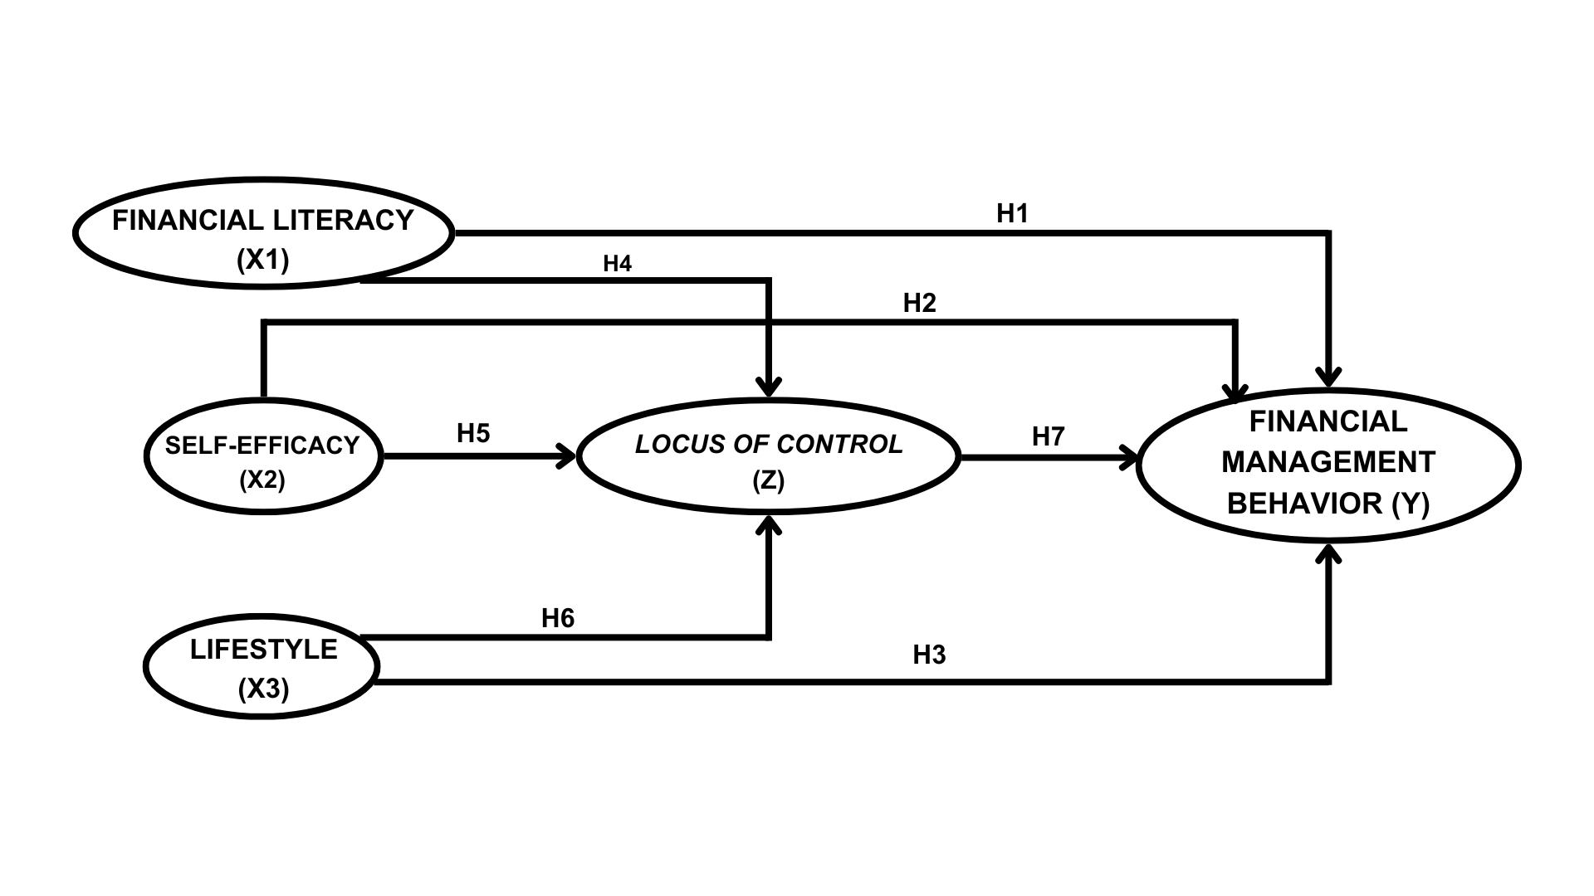

**Figure 1. Conceptual Framework**

Methods

In this research, a quantitative methodology was employed, incorporating initial observations alongside descriptive statistical analysis. The analytical method utilized was SEM-PLS (Structural Equation Modeling-Partial Least Squares). The target population comprised active students from the Faculty of Economics and Business at Bandar Lampung University, specifically those enrolled in the classes of 2021 to 2023, totaling 718 students. A random sampling technique was applied to select the sample, calculated using the Slovin formula, resulting in a sample size of 128 students representing all academic programs at Bandar Lampung University, adhering to specified criteria. Data analysis was conducted using the Smart-PLS version 4.1.0.3 software. Data collection was facilitated through Google Forms, employing a Likert scale ranging from 1 to 5, where a score of 1 signifies strong disagreement and a score of 5 indicates strong agreement.

Result and Discussions

**Results**

**Outer Model**

In the questionnaire that has been distributed according to the research criteria, 38 statements were obtained with test results that meet the requirements. However, based on the first test, there were some data that did not meet the qualifications and resulted in data processing that did not meet the data testing standards, so that several statements were removed from the previous ones to get 19 statements from the total sub-variables.

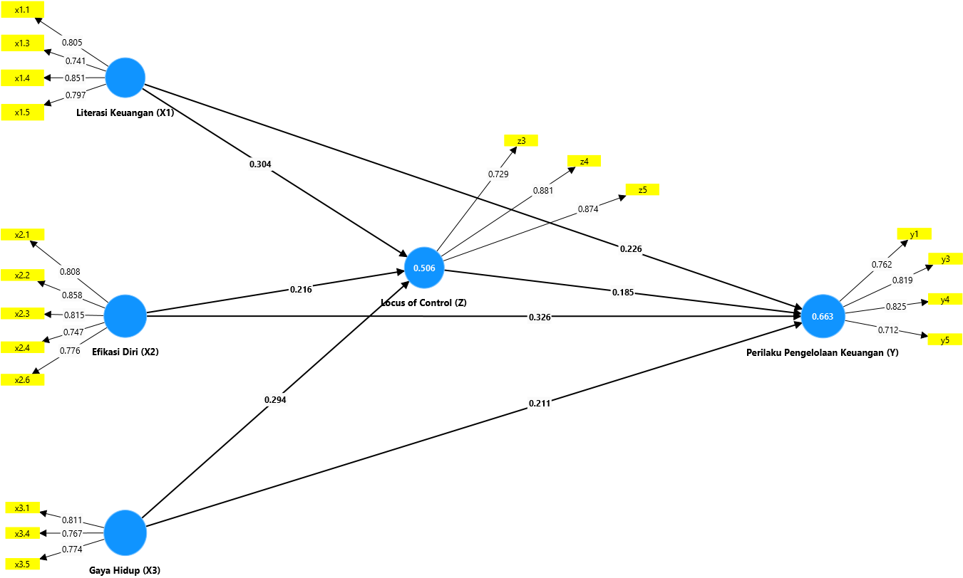

**Figure 2. Outer Loading Test Result**

Based on the results of testing the outer model, all variables in the model meet the validity criteria. Overall, all variables in the model show good validity.

**Inner Model**

**R-Square**

Hair et al stated that the r-square value with strong model prediction accuracy is at a value of 0.75, medium is at a value of 0.50 and the low level is at a value of 0.25.

**Table 1. R-Square Value**

|  |  |  |
| --- | --- | --- |
|  | **R-Square** | **R-Square Adjusted** |
| **LoC (Z)** | 0.506 | 0.494 |
| **FMB (Y)** | 0..663 | 0.653 |

The analysis of table 1 indicates that the R-Square value reveals the mediation variable accounts for 50.6% of the variation in the construct, categorizing it within the medium prediction range. In contrast, financial management behavior exhibits an R-Square value of 66.3%, reflecting a similar level of moderate predictive accuracy. The remaining percentage of variation is attributable to other variables not included in the model, which may influence the outcomes of the two examined variables.

**F-Square**

Hair et al not only stated about r-square but also stated about f-square, where the value of f-square has a small impact at 0.02, medium at 0.15 and a large one at 0.35.

**Table 2. F-Square Value**

|  |  |  |
| --- | --- | --- |
| **Variable** | **F-Squuare** | **Effect** |
| **S-E (X2) -> LoC (Z)** | 0.038 | Low |
| **S-E (X2) -> FMB (Y)** | 0.122 | Low |
| **L (X3) -> LoC (Z)** | 0.090 | Low |
| **L (X3) -> FMB (Y)** | 0.062 | Low |
| **FL (X1) -> LoC (Z)** | 0.094 | Low |
| **FL (X1) -> FMB (Y)** | 0.070 | Low |
| **LoC (Z) -> FMB (Y)** | 0.050 | Low |

Based on the f-square value test table presented, it can be concluded that all variables show low values, which indicates that almost all effects are weak.

**Hypothesis Test**

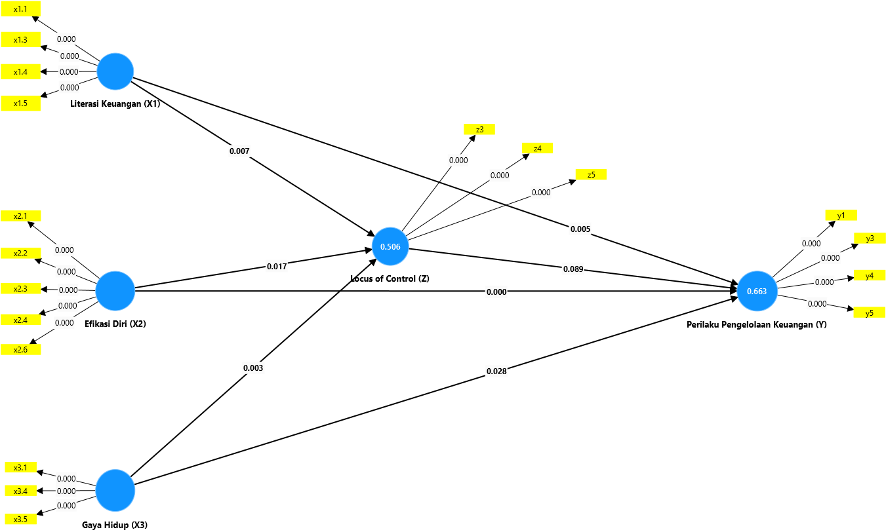

**Figure 3. Hypothesis Test Results in Smart-PLS 4.1.0.3**

Hypothesis testing is a form of testing to see and evaluate the relationship between variables, which wants to see whether the effect is significant or not. The general provision in this case is that a p value of less than 0.05 means that it is accepted and significant and if it is more than 0.05, it is rejected and not significant. This was conveyed by Hair et al.

**Table 3. Hypothesis Test Results**

|  |  |  |  |  |  |
| --- | --- | --- | --- | --- | --- |
| **Hypothesis** | **Original sample (O)** | **Sample mean (M)** | **Standard devitation (STDEV)** | **T-statistics (|O/STDEV|)** | **P values** |
| **S-E (X2) -> LoC (Z)** | 0.216 | 0.214 | 0.090 | 2.387 | 0.017 |
| **S-E (X2) -> FMB (Y)** | 0.326 | 0.331 | 0.094 | 3.487 | 0.000 |
| **L (X3) -> LoC (Z)** | 0.294 | 0.292 | 0.097 | 3.023 | 0.003 |
| **L (X3) -> FMB (Y)** | 0.211 | 0.213 | 0.096 | 2.203 | 0.028 |
| **FL (X1) -> LoC (Z)** | 0.304 | 0.306 | 0.113 | 2.687 | 0.007 |
| **FL (X1) -> FMB (Y)** | 0.226 | 0.227 | 0.081 | 2.788 | 0.005 |
| **LoC (Z) -> FMB (Y)** | 0.185 | 0.180 | 0.109 | 1.702 | 0.089 |

Based on the table above, it can be concluded that the six existing hypotheses can be accepted positively and significantly, in contrast to the seventh hypothesis which is positive but rejected. This rejection occurs because the value of the p-value it self is greater than 0.05, namely 0.089.

**Discussion**

**Financial Literacy on Financial Management Behavior**

In testing the hypothesis above, the independent variables have a really strong and positive influence on the dependent variable. Starting from financial literacy, which indicates that when students fill out the questionnaire, most of them agree with the statements. This indicates that when someone has a strong understanding of basic finance, their personal finances can be managed properly because of an awareness of the meaning of finance in accordance with existing aspects, such as income and expenses. This statement is in accordance with the research results from Hidayat and Paramita (2022), Ulumudiniati (2022), and Mashud et al. (2021).

**Self-efficacy on Financial Management Behavior**

The second independent variable demonstrates a significant impact on the dependent variable. This indicates that within the research context, participants concur that individuals possessing high self-efficacy are adept at managing their personal finances effectively. This encompasses the formulation of financial plans and the attainment of desired objectives. In essence, when students are capable of making informed financial decisions, the management of their personal finances becomes considerably more straightforward and systematic. This conclusion aligns with the findings of Ismail et al. (2017) and Ummah et al. (2021).

**Lifestyle on Financial Management Behavior**

The third independent variable, lifestyle, aligns with the previously mentioned variables, influencing behaviors related to effective financial management. This suggests that an individual's lifestyle significantly impacts their financial management practices, as students who possess an awareness of their lifestyle are more adept at handling their personal finances. Essentially, students who can regulate their daily expenditures tend to exhibit superior financial management skills, both in the short and long term. This finding is supported by the research conducted by Irawati and Kasemetan (2023) as well as Sufyati and Lestari (2022).

**Financial Literacy on Locus of Control**

The test results mean that the relationship between the two variables is good, positive, and significant. This means that people who have high general financial knowledge will be responsible for their own finances so that students can trust themselves in managing their finances. This is equivalent to what was found by Irawati and Kasemetan (2023), Rochmawati and Khoirunissa (2021), and Lukiastuti (2019).

**Self-efficacy on Locus of Control**

After the hypothesis is tested, it is proven that students with a large level of efficacy are easier to control their personal financial activities because students trust themselves in managing finances and are aware of their personal financial condition. With a high level of confidence, the confidence to solve financial management problems is getting better too. This is supported by the theory of Julian B. Rotter and research conducted by Sari (2022).

**Lifestyle on Locus of Control**

Lifestyle related to locus of control shows a relationship that can support a person in managing money spending for daily needs, especially in managing wants and needs. The influence of internal and external factors on a hedonic lifestyle can make it more difficult for individuals, but with a locus of control, the situation becomes more structured. This finding is in line with research by Irawati and Kesemetan (2023), Cahyani (2022), and Khoirunnisa (2021).

**Locus of Control on Financial Management Behavior**

The findings indicate a positive relationship between locus of control and financial management behavior; however, the hypothesis is ultimately rejected due to non-compliance with the established criteria. This suggests that other, more significant factors may influence various variables, implying that individuals who effectively manage their finances can do so independently of the locus of control belief in certain contexts. Furthermore, there are additional influences stemming from more dominant values related to some variables, as well as external factors that remain unexplored. This conclusion aligns with the research outcomes reported by Baptista et al. (2021).

Conclusion

Based on the results of the research and analysis that have been carried out, it can be concluded that:

1. Financial literacy, self-efficacy, and lifestyle have a positive and significant influence on students at the Faculty of Economics and Business, Bandar Lampung University, in managing their personal finances, even though with different backgrounds.
2. The three independent variables influence and are mediated by locus of control, which acts as confidence and self-control in decision-making and financial management steps.
3. The analysis of the dependent variable reveals that locus of control does not exert a significant effect; however, a positive correlation exists between the two constructs. This phenomenon can be attributed to the attitudes of students at the Faculty of Economics and Business, Bandar Lampung University, who exhibit a higher score on the independent variable in comparison to the mediating variable. Consequently, locus of control is unable to exert influence in the absence of support from additional independent variables.

The suggestions from researchers that can be given from the results of this study are:

1. For future researchers, the independent variables should be tested again with different settings, including aspects of income, status, and factors that influence student financial management behavior and locus of control more deeply and significantly.
2. For the readers, managing finances is crucial in everyday life, especially for college students, so in order to be prepared for the future, it is important to start understanding the basics of finance.

Acknowledgement

I would like to thank God, my parents, friends, and especially the lecturers who have guided and supported me in this research, as well as all the respondents who have taken the time.

References

’Ulumudiniati, M., & Asandimitra, N. (2022). Pengaruh Financial Literacy, Financial Self-Efficacy, Locus of Control, Parental Income, Love of Money terhadap Financial Management Behavior: Lifestyle sebagai Mediasi. *Jurnal Ilmu Manajemen*, *10*(1), 51–67. https://doi.org/10.26740/jim.v10n1.p51-67

Alifa Salsabila Hidayat, & R.A Sista Paramita. (2022). The Analysis of Financial Literacy, Financial Attitude and Locus of Control Toward Financial Behavior on UNESA’s Economic and Business Students. *Accounting and Finance Studies*, *2*(3), 157–176. https://doi.org/10.47153/afs23.4392022

Arofah, A. A. (2019). Financial literacy, self-efficacy, and financial behaviour of college students. *International Journal of Pedagogy and Teacher Education*, *3*(2), 129–138. https://jurnal.uns.ac.id/ijpte/article/view/17546

Austin, J. N., & MN, N. (2021). Perilaku, Sikap Dan Pengetahuan Keuangan Terhadap Kepuasan Keuangan. *Jurnal Manajerial Dan Kewirausahaan*, *3*(1), 61. https://doi.org/10.24912/jmk.v3i1.11288

Baptista, S. M. J. (2021). The Influence of Financial Attitude, Financial Literacy, and Locus of Control on Financial Management Behavior (Study Case Working-Age of Semarang). *International Journal of Social Science and Business*, *5*(1), 93–98. https://doi.org/10.23887/ijssb.v5i1.31407

Dare, S. E., van Dijk, W. W., van Dijk, E., van Dillen, L. F., Gallucci, M., & Simonse, O. (2023). How Executive Functioning and Financial Self-efficacy Predict Subjective Financial Well-Being via Positive Financial Behaviors. *Journal of Family and Economic Issues*, *44*(2), 232–248. https://doi.org/10.1007/s10834-022-09845-0

Hendrawati, E. (2019). Pengaruh Locus Of Control Terhadap Self Eficacy Dan Motivasi Berprestasi. *Journal of Chemical Information and Modeling*, *53*(9), 1689–1699.

Hilmi, R. Z., Hurriyati, R., & Lisnawati. (2018). *PENGARUH LOCUS OF CONTROL DAN PENGETAHUAN KEUANGAN TERHADAP PERILAKU PENGELOLAAN KEUANGAN MAHASISWA*. *3*(2), 91–102.

Kanserina. (2015). *Perilaku Konsumtif Mahasiswa Jurusan Pendidikan Ekonomi UNDIKSHA 2015*. *5*(1).

Lestari, S. I., & Pramukty, R. (2023). Pengaruh Locus of Control, Kepemimpinan Situasional, Dan Efikasi Diri Terhadap Kepuasan Kerja. *Musytari: Neraca Manajemen, Akuntansi, Dan Ekonomi*, *1*(8), 1–10.

Lown, J. M. (2011). 2011 oustanding AFCPE® Conference paper: Development and validation of a Financial Self-Efficacy Scale. *Journal of Financial Counseling and Planning*, *22*(2), 54–63.

Mashud, M., Mediaty, M., & Pontoh, G. T. (2021). The Effect of Financial Literature, Lifestyle and Income of Parents on Student Financial Management Behavior. *Journal of International Conference Proceedings*, *4*(3), 256–264. https://doi.org/10.32535/jicp.v4i3.1315

Nurjanah, R., Surhayani, S., & Asiah, N. (2022). Faktor Demografi, Literasi Keuangan, Sikap Keuangan Terhadap Perilaku Pengelolaan Keuangan Pada Umkm Di Kabupaten Bekasi. *Jurnal Akuntansi Bisnis Pelita Bangsa*, *7*(01), 1–16. https://doi.org/10.37366/akubis.v7i01.431

Pinasti, W. (2011). Pengaruh Self-efficacy, Locus of Control dan Faktor Demografis Terhadap Kematangan Karir Mahasiswa UIN Syarif Hidayatullah Jakarta. *Skripsi*.

Pradiningtyas, T. E., & Lukiastuti, F. (2019). Pengaruh Pengetahuan Keuangan dan Sikap Keuangan terhadap Locus of Control dan Perilaku Pengelolaan Keuangan Mahasiswa Ekonomi. *Jurnal Minds: Manajemen Ide Dan Inspirasi*, *6*(1), 96. https://doi.org/10.24252/minds.v6i1.9274

Rahman, A., Yousida, I., Kristansi, L., & Paujiah, S. (2020). Pengaruh Pengetahuan Keuangan, Perencanaan Keuangan Dan Kontrol Diri Terhadap Perilaku Pengelolaan Keuangan Pada Mahasiswa Yang Menjalankan Praktik Bisnis Dikota Banjarmasin. *Jurnal Mitra Manajemen*, *4*(9), 1405–1416. https://doi.org/10.52160/ejmm.v4i9.466

Sufyati HS, & Alvi Lestari. (2022). Pengaruh Literasi Keuangan, Inklusi Keuangan dan Gaya Hidup Terhadap Perilaku Keuangan Pada Generasi Milenial. *Jurnal Multidisiplin Madani*, *2*(5), 2415–2430. https://doi.org/10.55927/mudima.v2i5.396

Susanti, R., & Wangdra, R. (2024). Pengaruh Literasi Keuangan, Sikap Keuangan dan locus of control Terhadap Perilaku Manajemen Keuangan Mahasiswa Jurusan Akuntansi. *ECo-Buss*, *6*(3), 1152–1164. https://doi.org/10.32877/eb.v6i3.1090

Ummah, S. M., Susyanti, J., & Priyono, A. A. (2022). Pengaruh Sikap Keuangan, Pengetahuan Keuangan, Efikasi Diri Keuangan Terhadap Perilaku Manajemen Keuangan Melalui Pengendalian Diri Sebagai Variabel Intervening. *Jurnal Riset Manajemen*, 19–32.

Widyakto, A., Liyana, Z. W., & Rinawati, T. (2022). The influence of financial literacy, financial attitudes, and lifestyle on financial behavior. *Diponegoro International Journal of Business*, *5*(1), 33–46. https://doi.org/10.14710/dijb.5.1.2022.33-46

Youla Diknasita Gahagho, Tri Oldy Rotinsulu, & Dennij Mandeij. (2021). Pengaruh Literasi Keuangan Sikap Keuangan Dan Sumber Pendapatan Terhadap Perilaku Pengelolaan Keuangan Mahasiswa Fakultas Ekonomi Dan Bisnis Unsrat Dengan Niat Sebagai Variabel Intervening. *Jurnal EMBA*, *9*(1), 543–555.