STATEMENT OF AUTHORSHIP AND DISCLOSURE OF POTENTIAL CONFLICT OF INTEREST FORM

MANDATORY SUBMISSION FORM Manuscript No. 561
I am aware of the contents and consent to the use of my name as an author of a manuscript entitled:
THE EFFECT OF OWNERSHIP STRUCTURE ON DIVIDEND POLICY OF MANUFACTURING COMPANIES LISTED ON IDX AND MYX FOR THE 2015-2019 PERIODS

That is to be considered for publication in the Journal of Management and Business (MABIS).
I hereby certify that, to the best of my knowledge:
- This manuscript is not currently under consideration, in press or published elsewhere.
- This manuscript is truthful original work without fabrication, fraud or plagiarism including but not limited to self-plagiarism.
- I have made an important scientific contribution to this study, I am familiar with the primary data, and I have read the entire manuscript and take responsibility for its content.
- With the publication, I submit full copyright to the Journal MABIS, FBE UBAYA. Transfer of copyright including the right to reproduce in print and online media of similar nature and translations. It also includes the right to include article for on-line dissemination and other types of media information, in accordance with SK Dirjen DIKTI No. 2050/E/T/2011.
- No financial support or benefits have been received by me, by any member of my immediate family, or any individual or entity with whom or with which I have a significant relationship from any commercial source which is related directly or indirectly to the scientific work which is reported on in the article except as described below. (I understand an example of such support would be a consulting fee, support for research activities or a gift.)
- Moreover, neither I, nor any member of my immediate family, nor any individual or entity with whom or with which I have a significant relationship has a financial interest in the subject matter discussed in the manuscript. (I understand an example of such a financial interest would be a stock interest in any business entity which is included in the subject matter of the manuscript or which sells a product relating to the subject matter of the manuscript.)
Exceptions to points 4 and/or 5: Please describe here, using a separate sheet if necessary, any financial interests/arrangements with one or more organizations that could be perceived as a real or apparent conflict of interest in the context of the subject of your manuscript:
___________________________________________________________________________
-
___________________________________________________________________________

___________________________________________________________________________

___________________________________________________________________________

If any commercial interests/arrangements are described above, I understand that the staff of the Journal will keep this information confidential but communicate it to the handling Associate Editor and – if necessary – to the reviewers. I also understand that if the manuscript is accepted, the Editors will discuss with me the manner in which such information is to be communicated to the reader. I hereby grant permission for any such information to be included with publication of the manuscript in the Journal of Management and Business MABIS).

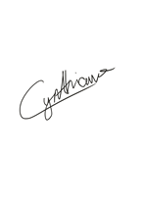
Please list all authors and at least one author sign in table below:
Name of the Author(s) | 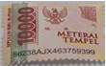  Signature | Email
Cynthia Valentina | (Materai 10.000) | cynthiavalentina16@yahoo.co.id
Liliana Inggrit Wijaya |  | liliana@staff.ubaya.ac.id
Endang Ernawati | 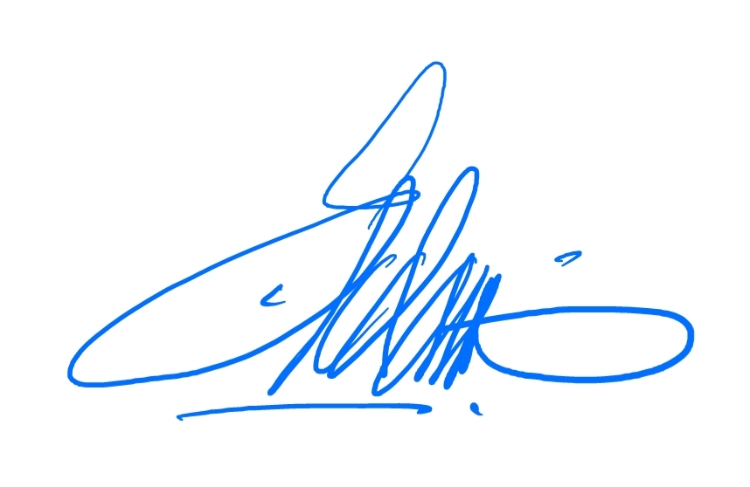 | endang@staff.ubaya.ac.id

Please sign, and send it through fax or scan and email it to the Editor’s Office:
Fax : +62 031 2981131
Email : jurnalmabis@unit.ubaya.ac.id

